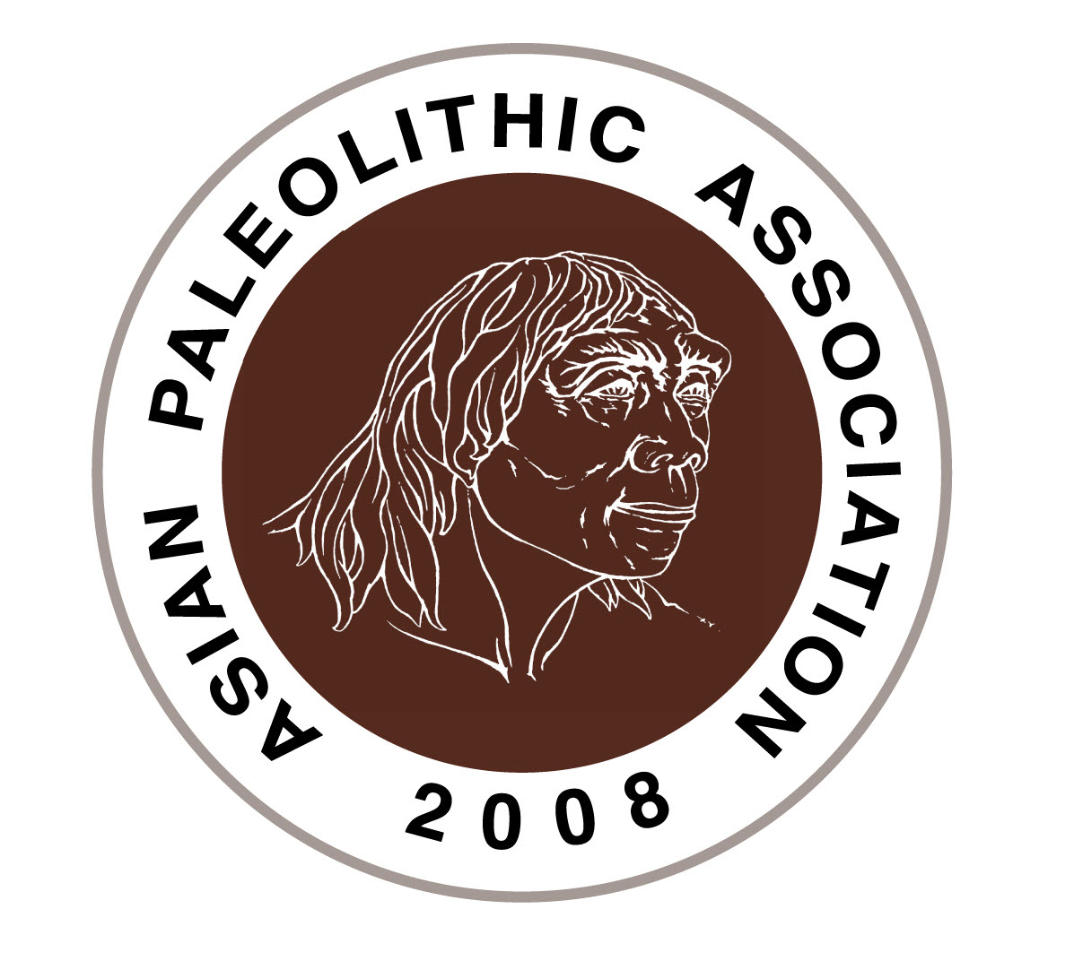The 12th Meeting of the Asian Paleolithic Association

Sendai, Japan, June 20th – 24th, 2025

**Registration Form**

Title: Prof. / Dr. / Student / Others Sex: male / female / custom ( )

Family Name:

Given (and Middle) Name:

Nationality:

Affiliation:

Post address:

E-mail:

**Participation**

I will participate in the meeting and give an oral or a poster presentation.

I will participate in the meeting but give no presentation.

I will participate in the post-conference excursion.

**Invitation letter**

Please check the box, if you need an invitation letter.

**Dietary restrictions**

Please check the box, if you prefer to food for vegans/vegetarians. We will prepare a lunch box for June 21st and 22nd.

Please submit the Registration Form to [apajapan2025@gmail.com](mailto:apajapan2025@gmail.com) by March 1st, 2025.